 | Year: 3 | Subject: Maths
Title:
Addition and Subtraction
What key knowledge do I need to have before this unit?
How to add and subtract two digit numbers including exchanging.
Knowing number bonds to 10.
Mentally add and subtract 1s from a 2 digit number.
Key outcomes:
What I need to know by the end of this unit of work:
- Use of number bonds within 10
- Adding and subtracting 1, 10s and 100s
- Spotting patterns within numbers
- Adding 1s across 10 and 10s across 100
- Subtracting 1s across 10 and 10s across 100
- Adding and subtracting two numbers with no exchange
- Adding two numbers across a 10 and 100
- Subtracting two numbers across 10 and 100
- Addition and subtraction of two and three digit numbers
- Complements to 100
- Estimation
- Inverse operations and making decisions.
Key knowledge: | Key Vocabulary: | Definition:
Confident in recall of number bonds to 10 and 100 in a variety of contexts.  Confidently understand and use place value to help with addition and subtraction.  Adding across two and three digit numbers.  Adding and subtracting 10s and 100s.  Confident use of number bonds to support understanding.  Exploring what changes and stays the same when adding multiples of 1, 10 and 100.  Spotting the pattern in a number sequence and being able to continue the sequence.  Fluent in bonds to 100.  Finding connects between calculations, relating what we already know to a new number sentence.  Confident in discussing and creating estimates. | Number bonds  Addition  Subtraction  Estimating  Inverse  Operations | A pair of numbers that always add together to make another, larger number.  The process of calculating the total of two or more numbers or amounts.  Taking away one or more amounts from one another to create a small number/amount.  A careful guess as to the amount, size or value of something.  The opposite of the action carried out.  The mathematical process used to complete a calculation.


&
Addition

Subtraction

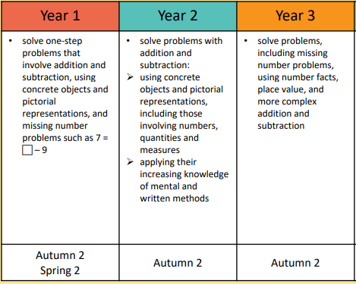
1

