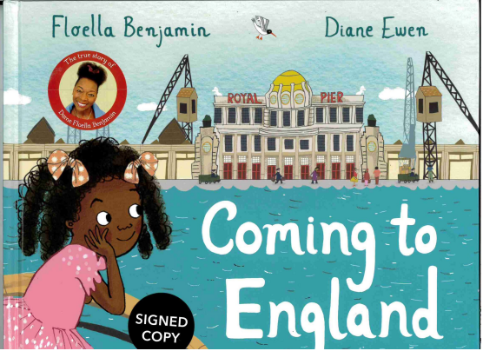
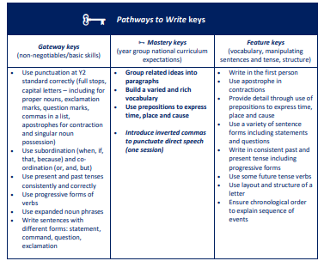
1
Writing outcome:
To write letters from Floella to her Grandmother telling her about settling into life in the UK.
Greater depth writing outcome:
To include a letter from Grandmother in response to one of Floella’s letters.

