 | Year: 2 | Subject: Computing
Title:

Data and information – Pictograms
What key knowledge do I need to have before this unit?
Objects can be counted, grouped and labelled
Computers are not intelligent and require input from humans
Properties can be used to group objects
A group of objects can be grouped in different ways
Key outcomes:
What I need to know by the end of this unit of work:
- Information/data needs to be organised effectively for counting and comparing – Tally charts.
- What pictograms are and why using a computer to create them is better.
- What data collection method is best for different information?
- What an attribute is and how we can use this for data gathering.
- Attributes can be used to describe people.
- What a block diagram is and when should I share data?
Key knowledge: | Key Vocabulary: | Definition:
Information is what we can understand from looking at data.  Data about different groups can be recorded and presented by using pictograms, tally charts and block charts. This data can answer questions and solve problems.  Computers can help us by allowing us to put different objects into groups.  Computers can be programmed to count the amounts in each group. -For example, when your teacher takes the class register, the computer program can count how many ticks and crosses there are. The computer can then tell your teacher how many children are in class.  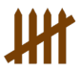  Tallying helps us to record as we count. We chunk into groups of five, with the first four counts looking like sticks, and the fifth count making the ‘gate.’  Tally charts are used to collect data about the number in each group quickly.  A pictogram is a chart that uses pictures to display data. They can be made using pens or paper, or they can be made using a computer. The pictogram on the right shows the favourite fruits of a group of school children. Each piece of fruit shows what each child selected. Block charts work in a similar way to pictograms, except each object is presented as a block. The block diagram on the right presents how different children get into school. | Organise  Tally chart  Pictogram  Compare  Attribute  Conclusion  Block diagram | Group things together.  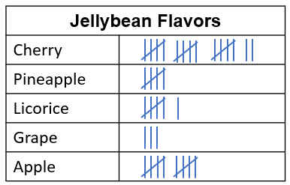  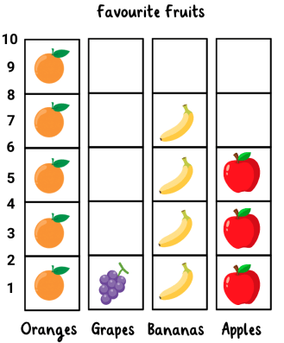  What is the same and what is different with the information you find.  A feature, trait, or property of an object.  It brings together the key information or story points.  