 | Year: 3 | Subject: Maths
Title:
Fractions
What key knowledge do I need to have before this unit?
Prior knowledge of halves, quarters and thirds
Key outcomes:
What I need to know by the end of this unit of work:
- Understand the denominators of unit and non-unit fractions
- Compare and order fractions
- Understand the whole
- Fractions and scales
- Fractions on number line
- Equivalent fractions

National Curriculum Links: | Key Vocabulary: | Definition:
• Recognise, find and write fractions of a discrete set of objects: unit fractions and non-unit fractions with small denominators  • Compare and order unit fractions, and fractions with the same denominators  •Measure, compare, add and subtract: lengths (m/cm/mm); mass (kg/g); volume/capacity (l/ml)  • Recognise and show, using diagrams, equivalent fractions with small denominators | Numerator  Denominator  Unit fraction  Non-unit fraction  Part  Whole  Equivalent  Equal  Greater  Smaller | The number above the line in the fraction. This shows us how many parts of the whole we have.  The number below the line. This shows us how many parts make the whole.  A fraction with a numerator of 1.  A fraction with a numerator of more than 1.  One piece or section of a whole thing.  The entire amount.  Equal to/same as.

Fractions

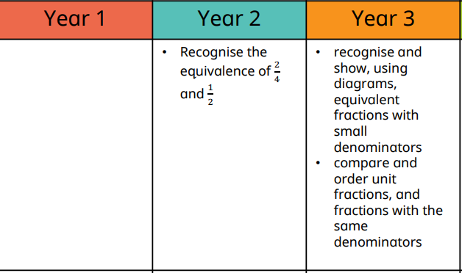
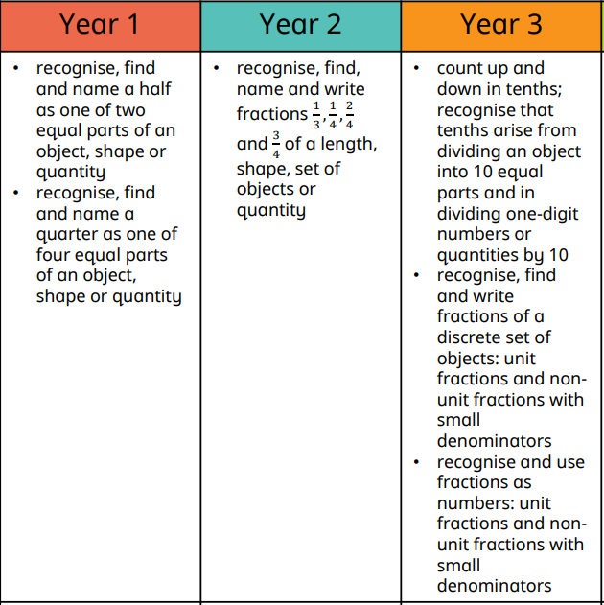
Recognise and Write Compare

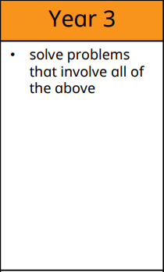
Solve Problems

