 | Year: 2 | Subject: Design and Technology
Title:
Mechanisms: Wheels and axles
What key knowledge do I need to have before this unit?
Understand the development of existing products: What they are for, how they work, materials used. How to make my design using appropriate techniques. The use mechanisms e.g. levers and sliders in products. How to use tools safely e.g. scissors. How to assemble, join and combine materials and components together using a variety of temporary methods e.g. glues or masking tape.
Key outcomes:
What I need to know by the end of this unit of work:
- I can identify wheels and axles.
- I can explain how wheels help a vehicle move.
- I can design a simple vehicle.
- I can make a model with wheels and axles.
- I can evaluate my finished vehicle.
Key knowledge: | Key Vocabulary: | Definition:
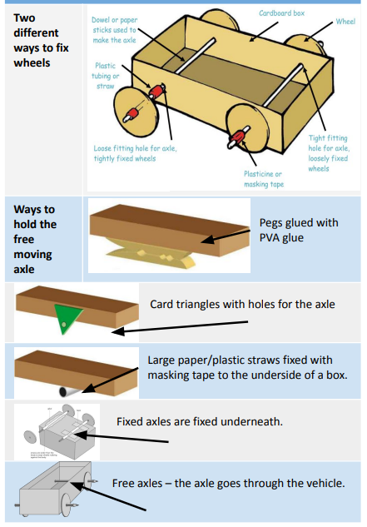 | vehicle  wheel  axle  free axles  washer  chassis  moving parts  saw  clamp  tools  durable  functional | Something used to carry and move people or things. Cars, buses and airplanes are vehicles.  A circular object that turns round. It can be fixed to a vehicle like a car or bicycle to allow the vehicle to move easily on the ground.  A rod that enables a wheel to rotate. The wheel can rotate freely on the axle or be fixed to, and turn with the axle.  The axles go through the vehicle.  A flat ring of rubber, metal or other material used with a nut and bolt to make a tight fit.  The frame or base on which a vehicle is built.  A part in a machine or product that has power to move.  A tool with a thin metal blade that has sharp teeth along the edge. Saws are used for cutting hard materials such as wood or metal.  A device used to fasten, support or press together two or more objects or pieces.  An instrument that is usually held with the hands and helps one to do something.  Not easily broken or worn out, lasting and sturdy.  Having a practical purpose.

