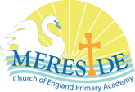 | Year: 3 | Subject: RE
Title:

How can a Mosque help us understand the Muslim faith?
What key knowledge do I need to have before this unit?
The beliefs of Muslims.
The holy place in which Muslims pray.

Key outcomes:
What I need to know by the end of this unit of work:
Know and understand the significance of a Mosque.
Know what rituals Muslims follow.
Sacred Muslim artefacts.
Key knowledge: | Key Vocabulary: | Definition:
Allah means God.  Muslims go to a Mosque to pray to Allah.  There are routines in which Muslims follow inside the Mosque.  Muslims face a certain way when praying to Allah.  The Hija is a pilgrimage, a journey of God that Muslims make.  The pilgrims visit the Kabah in Mecca and walk around it seven times.  Muslims believe that the Kabah was built by the Prophet Abraham. | Mosque  Routines  Pray  Pilgrimage  Journey  Prophet | A Muslim place of worship.  A sequence of actions regularly followed.  Address a prayer to God or another deity.  A devotional prolonged journey on foot to a destination. Often where individuals show personal growth.  An act of traveling from one place from another.  A person regarded as an inspired teacher or proclaimer of the will of God.

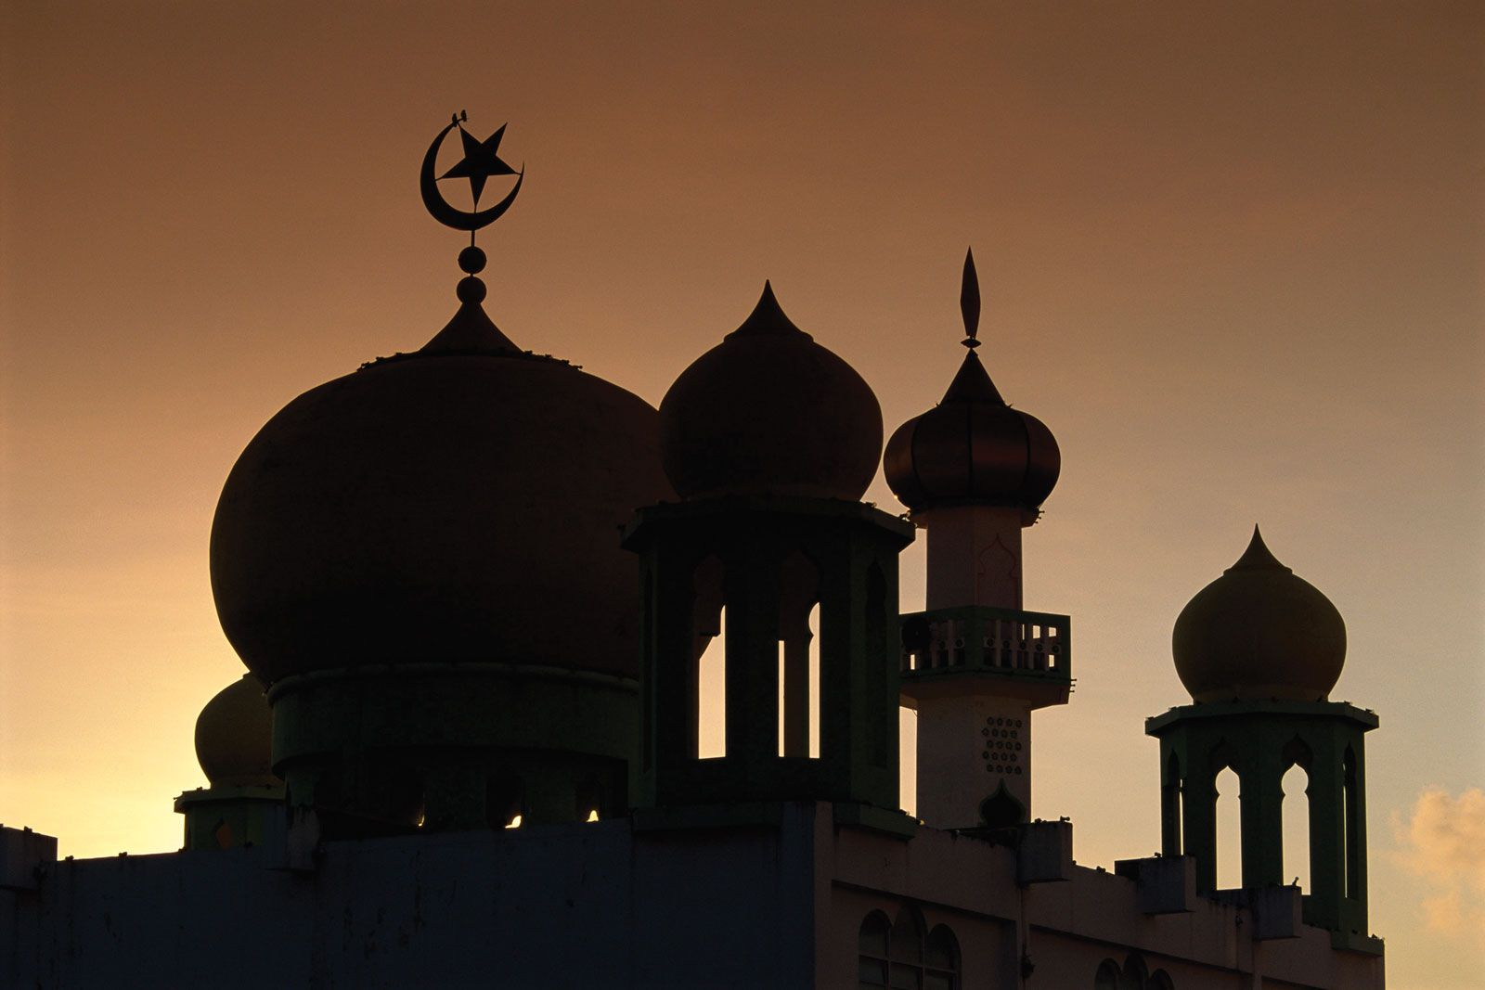
How can a Mosque help us understand the Muslim faith?
How can a Mosque help us understand the Muslim faith?
How can a Mosque help us understand the Muslim faith?

