 | Year: 2 | Subject: Design and Technology
 | Title: Textiles – templates and joining
What key knowledge do I need to have before this unit?
Fine motor skills – using a range of small tools.
Thought about the user and purpose of products
Creating with materials:
Explored and used different fabrics.
Cut and joined fabrics with simple techniques.
Key outcomes:
What I need to know by the end of this unit of work:
- I can evaluate existing products
- I can evaluate materials and a range of joining techniques
- I can draw a design based on a design criteria
- I can use a design criteria to guide the making process
- I can evaluate my product against the design criteria

Key knowledge: | Key Vocabulary and  definition:  Product - An item that is used by a customer.  Running stitch - a sewing stitch made by passing the needle in and out repeatedly with short, even stitches.  Fabric - Cloth or material made through weaving, knitting, spreading, crocheting, or bonding.  Pattern - A template used to cut out shapes for sewing projects.  Needle - A long, thin instrument with a sharp point at one end used for sewing.  Mock up - quick 3-D modelling using easy to work and cheaper materials and temporary joints. Useful for checking proportions and scale.  Appliqué - to attach a decorative fabric item onto another piece of fabric by gluing and/or sewing  Joining fabrics - 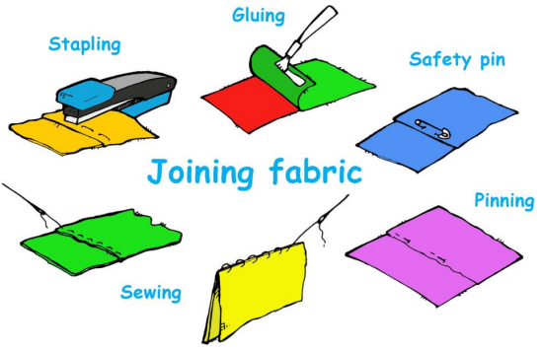
Design and technology is a process that creators, designers and inventors go through.
There are many different fabrics and materials that can be used to create a product but not all are suitable.
There are a range of joining techniques to bring materials together but not all are suitable.
During the design process more than one design is created and the best is chosen.
Creating a mock up highlights anything that needs changing in the design before making.

