 | Year: 2 | Subject: Design and Technology
 | Title: Food technology – preparing fruits and vegetables
What key knowledge do I need to have before this unit?
Fine motor skills – using a range of small tools.
Thought about the user and purpose of products
Creating with materials:
Explored and used different fabrics.
Cut and joined fabrics with simple techniques.
Key outcomes:
What I need to know by the end of this unit of work:
- I can evaluate existing products
- I can explain food hygiene rules and the techniques needed to use food preparing equipment
- I can draw a design based on a design criteria
- I can use a design criteria to guide the making process
- I can evaluate my product against the design criteria

Key knowledge: | Key Vocabulary and  definition:  Product - An item that is used by a customer.  Fruit – plant or tree’s edible seed with envelope.  Vegetable – plant used for food.  Pith – the soft white lining inside fruit such as oranges.  Salad – a cold dish of fresh and/or cooked vegetables or fruit.  Sensory evaluation – subjective testing of foods where senses are used to evaluate qualities such as appearance, smell, taste, texture (mouth feel).  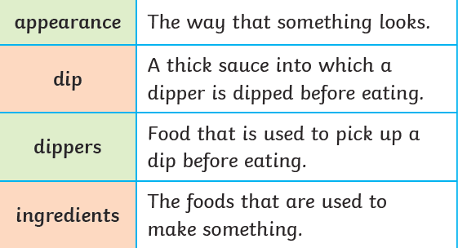
Design and technology is a process that creators, designers and inventors go through.
