 | Year: 3 | Subject: Art
Title:
Roman coil pots
What key knowledge do I need to have before this unit?
EYFS: Lines, colour names and simple form and construction
Year 1: tone, colour and colour mixing, wire sculpture
Year 2: cast shadows, hatching colour theory

Key outcomes:
What I need to know by the end of this unit of work:
I can match colours using the primary colours.
I can explain what halftone is and how it is normally made.
I can list the three main types of Roman art.
I can complete an artist study.
I can create a design use evaluated ideas.
I can compare artist’s work.
I can use air-drying clay to create a piece that has a purpose.
I know how and can join clay in different ways.

Key knowledge: | Key Vocabulary: | Definition:
Observational drawing (using a pencil and replicating exactly what is there)  Tint, tone and shade can be used to change the hue of a colour.  Making images look realistic with shading – cross hatching.  When light hits objects and people/animals it casts a full light shadow.  Learning about types of Roman art.  Collaborative art to show a story.  Using slip, scoring, smoothing and sticking methods with clay. | Medium  Tint, tone and shade  Halftone  Slip  Score  Smooth | pencil, pens, charcoal, soft pastel, oil pastel, paint, watercolour, powder paint.  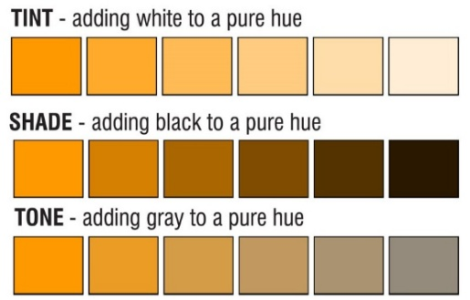    Mix clay and water to create an adhesive.  To create lines in pot to help hold two piece together  To rub the clay to smooth out lines.

