 | Year: 3 | Subject: Maths
Title:
Length and Perimeter
What key knowledge do I need to have before this unit?
I can measure lengths in cm or m.
Understanding of the greater than and less than symbols
Counting in 100s
Addition with and without exchanging
Key outcomes:
What I need to know by the end of this unit of work:
- I can measure in m, cm and mm
- I can identify equivalent lengths
- I can compare lengths
- I can add lengths
- I can subtract lengths
- I can measure and calculate perimeter
National Curriculum Links: | Key Vocabulary: | Definition:
Measure, compare, add and subtract: lengths (m/cm/mm); mass (kg/g); volume/capacity (l/ml)  Measure the perimeter of simple 2-D shapes | Centimetres  Metres  Millimetres  Measure  Intervals  Exact  Compare  Partition  Convert  Equivalent  Perimeter  Opposite | A metric unit of length  The exact size, weight or amount of something  A group of numbers that includes all numbers between the beginning and end.  Precise  Change  The same as or equal to another  The distance all the way around the outside of a 2D shape.

Length and Perimeter

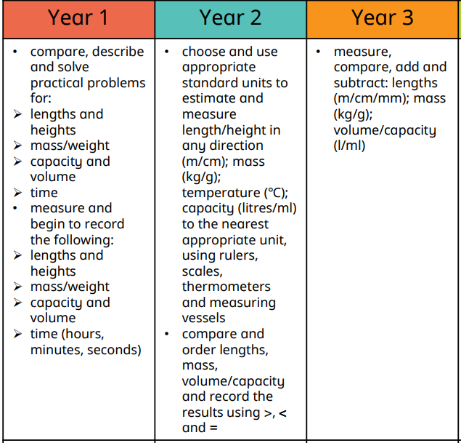
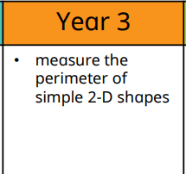
Using Measures Perimeter, Area and Volume

