 | Year: 3 | Subject: Science
Title:
Nutrition and Diet
Sustainability
What key knowledge do I need to have before this unit?
Know what fruit and vegetables are.
Know what are healthy foods and unhealthy foods.
Understand that our body needs food to survive.
Key outcomes:
What I need to know by the end of this unit of work:
- Know and understand the five food groups
2. What a balanced diet is
- Compare diets
- Understand animal diets.
- Understand what is food waste and how we can reduce it.
Key knowledge: | Key Vocabulary: | Definition:
Understand the five main food groups and what are body needs to be healthy.  Know what is meant by a balances diet.  Understand how our body absorbs nutrients from food.  Understand what animals need to survive.  Know that an herbivore is an animal that eat plants.  A carnivore is an animal that eats other animals.  Omnivore is an animal that eats other animals and plants. | Carbohydrates  Proteins  Dairy  Fats  Sugars  Fruit and vegetables  Herbivore  Carnivore  Omnivore  Sustainability | The bodies major source of energy can be found in foods such as bread, cereals, pasta and rice.  Builds, maintains and replaces the tissues in your body, can be found in foods such as eggs, beans, fish and meat.  Food made from the milk of an animal.  Nutrients in food that the body uses to build cell membranes, nerve tissues and hormones. Found in foods such as avocados, oil, butter, fried foods and nuts.  Substances used to make food and drinks sweet.

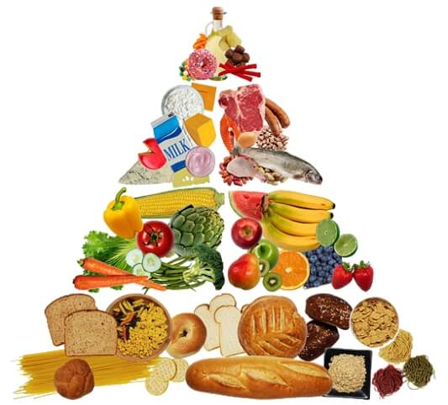

Nutrition and Diet

Nutrition and Diet

