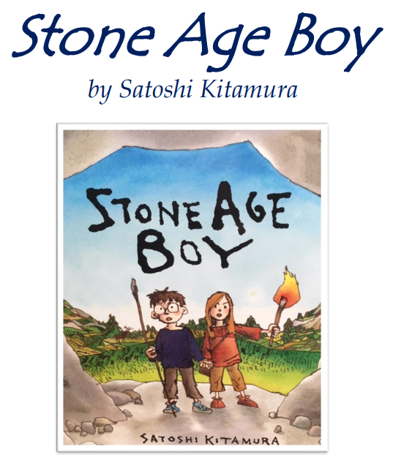
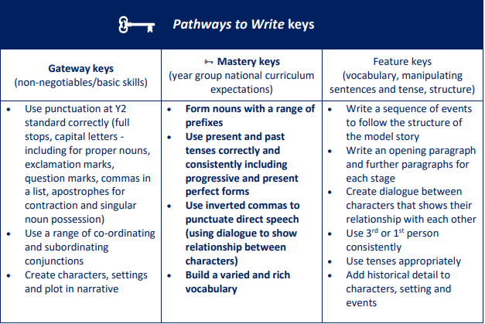
Writing Outcome: Historical Narrative
Write the story from the point of view of the boy.

