 | Year: 2 | Subject: Religious Education
Title:
Creation: Who made the World?
What key knowledge do I need to have before this unit?
Christians believe God created the universe
The Earth and everything in it are important to God
God has a unique relationship with human beings as their Creator and sustainer
Humans should care for the world because it belongs to God
Christians believe in God, and that they find out about God in the Bible
Christians worship God and try to live in ways that please him
Key outcomes:
What I need to know by the end of this unit of work:
- The story of Creation from Genesis 1:1-2.3 simply
- The story of creation is the beginning of the ‘big story’ of the bible
- Say what the story tells Christians about God, Creation and the world
- How Christians say thank you to God for the Creation
- Think, talk and ask questions about living in an amazing world
Key knowledge: | Key Vocabulary: | Definition:
The world was created in seven days.  The first day God created light.  The second day God created the clouds and the oceans.  The third day God created plants and trees.  The fourth day God created the stars and the moon.  The fifth day God created birds and fish.  The sixth day God created man and animals.  The seventh day God rested.  Christians believe that we should look after Gods creations.  Harvest Festival is a time when Christians say thank you to God the creator.  Christians show thanks by giving to food banks and charities. | Creation  Christian  God  Bible  Thankfulness  Harvest | The act of making, producing or inventing something.  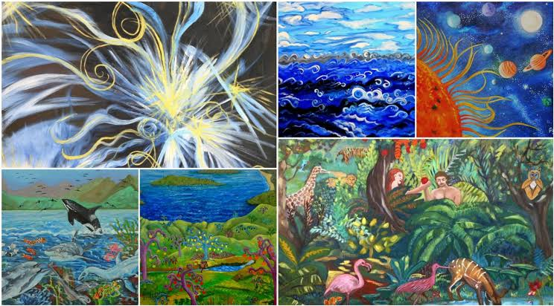  A person who believes in Jesus Christ and follows his teaching.  The eternal, supreme being who created and preserves all things.  The holy book sacred to Christians.  A feeling of happiness or gratitude that comes from something or someone.  The process or period of gathering in crops.  