 | Year: 2 | Subject: Geography
Title:
Map makers

What key knowledge do I need to have before this unit?
Understanding what is a map.
What a continent and country is.
Know where the UK is on a map.
Key outcomes:
What I need to know by the end of this unit of work:
- I can use compass points to navigate around a map
- I can use what I know about aerial view to create a plan of the classroom
- I can follow a map and add a key to show places of interest around the school
- I can design a map using key features
- I can create a 3D map using our own map designs
Key knowledge: | Key Vocabulary: | Definition:
A map is a drawing of an actual place that uses lines and symbols to represent real-life objects. People have used maps for hundreds of years to help them travel from place to place.  There are many different types of maps, such as: Sketch maps Road maps Ordnance Survey maps Climate maps.  A mapmaker is called a cartographer. The oldest maps were made on clay tablets.  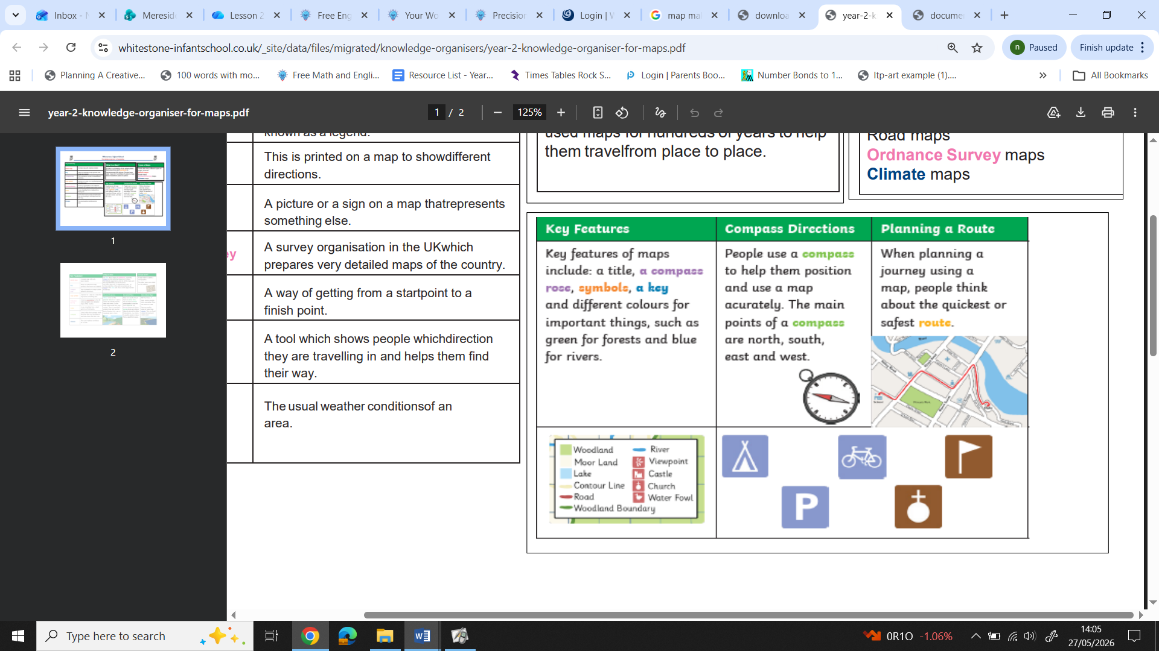 | Human features  Physical geography  Compass rose  Aerial photograph  Key  Route  Fieldwork  Direction | Objects that have put there by humans  Objects that are there naturally  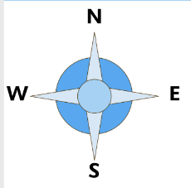  A tool to show direction. Key directional points – North, South, East, West  A photograph taken from above  Helps us understand map symbols. Also known as a legend.  A way of getting from a start point to a finish point.  Learning outside the classroom  The way something goes

