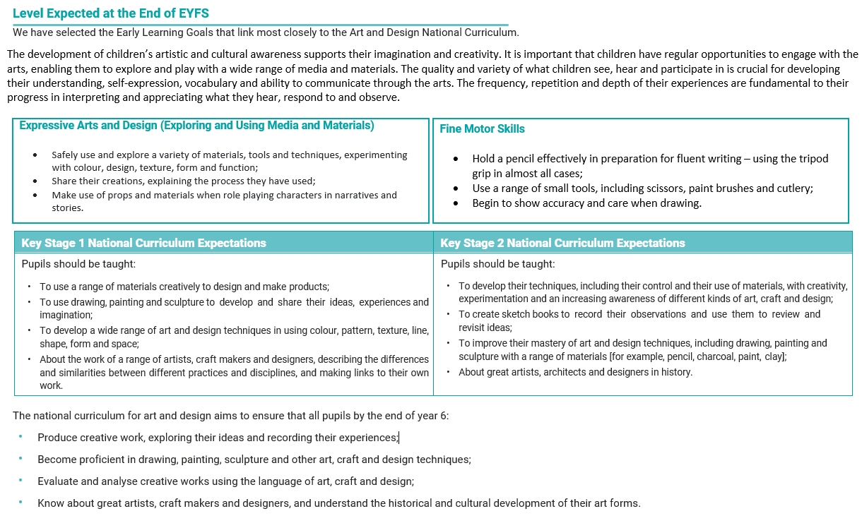
Sketchbooks
EYFS | Year 1 | Year 2 | Year 3 | Year 4 | Year 5 | Year 6
 | Understand that a sketchbook is owned by the pupil for experimentation and exploration.  Begin to demonstrate their ideas through sketches.  Show exploration and experimentation using a variety of media to develop techniques thorough mark making, printing, painting.  Plan their art using a range of techniques sketches / notes / discussions | Continue to build understanding that sketchbooks are places for personal experimentation.  Understand that the way each persons’ sketchbook looks is unique to them.  Create links with an artist and show this in their sketchbooks through visual notes.  Explain how other artists’ have used different techniques e.g., shape, colour, pattern.  To record exploration and experimentation of the qualities of different media.  Use their sketchbooks as a mode to record emotions and feelings | Continue to build understanding that sketchbooks are places for personal experimentation.  Understand that the way each persons’ sketchbook looks is unique to them.  Deconstruct and discuss an original artwork expressing feelings.  Create notes in their sketch books about techniques used by artists.  Collect information, sketches and techniques Annotate sketches to explain ideas.  Suggest improvements to their work by keeping notes in their sketch books.  Explore the qualities of the media that is studied. | Understand that artists use sketchbooks for different purposes and that each artist will find their own ways of working in a sketchbook.  Use their sketch books to adapt and improve their original ideas.  To collect and arrange sketches, mediums, techniques and information.  Create notes about the purpose of their work in their sketch books.  To adapt and refine ideas as they progress using annotations. | Embed that artists use sketchbooks for different purposes and that each artist will find their own ways of working in a sketchbook.  Use their sketchbooks as a mode to record the learning journey.  To imaginatively develop ideas that explore a theme.  To present collected information, sketches and resources imaginatively in sketchbooks.  To experiment and practice using a range of materials to develop ideas further, building and recording their knowledge visually.  To compare sketchbook ideas and give supportive and constructive feedback on peer’s development. | Embed that artists use sketchbooks for different purposes and that each artist will find their own ways of working in a sketchbook.  Imaginatively and thoughtfully develop their ideas from starting points.  To record detailed notes and quotes explaining their drawings and ideas.  To comment on changing ideas using visual language as they progress.  Make visual notes to capture, consolidate and reflect upon the artists studied.  To spot the potential in unexpected results to develop ideas further.  Explore ideas relating to design e.g. inspiration, source, materials, textures, colours, mood, lighting.

Drawing and Line pencil, wax, chalk, ink, pen, brushes, sticks, pallet knifes, pastels, charcoal, rubbers etc.
EYFS | Year 1 | Year 2 | Year 3 | Year 4 | Year 5 | Year 6
Begin to use a variety of media – e.g. finger, stick, pencil, coloured pencils, crayons, chalk.  Use drawings to tell a story from retelling or from imagination.  Investigate different lines - thick, thin, wavy, straight.  Explore different textures and experiment with mark making to illustrate these.  Drawings show growing accuracy. | Extend the variety of media to include charcoal, felt tips and pastels.  Explore different textures and experiment with mark - building on previous experience, naming, copying, describing and rubbing.  Observe and draw landscapes as accurately as possible, some small discussion of proportion and where the sky is.  Observe patterns in the natural and man-made world.  Encourage accurate drawings.  Sketch objects in both the natural and man-made world.  Investigate tone by drawing light/dark lines, shapes and patterns.  Name, match and draw lines/marks from observation and invent.  Work collaboratively.  Shade by smudging. | Continue as Year 1 to experiment with tools and surfaces with increasing control.  As Year 1, plus:  Continue to draw a way of recording experiences and feelings.  Look at drawings and comment thoughtfully.  Begin to discuss use of shadows (cast shadow), use of light and dark.  Sketch to make quick records of something.  Work out ideas through drawing.  Experiment with shading through hatching and stippling.  Investigate the sighting/measuring method. | As Year 2, plus:  Experiment with the potential of various pencils (2B - HB) to show tone, texture etc.  Encourage close observation of objects in both the natural and man-made world.  Experiment with shading through cross hatching.  Continue to discuss shadows (full light shadow).  Begin to show an awareness of objects having a third dimension.  Draw both the positive and negative shapes i.e. draw both the outline of the object and the shapes it creates within it.  Experiment with the grid method.  Make initial sketches as a preparation for painting and other work.  Encourage drawings that are more accurate.  Work on a variety of scales, A4 and larger. | As Year 3, plus:  Continue to discuss shadows (shadow edge shadowing).  Introduce the concepts of scale and proportion.  Experiment with shading through contouring.  Encourage more accurate drawings, building on their work to include proportion, placement and shape.  Drawing from direction.  Select own materials.  Work from a variety of sources including observation and photographs to develop their own work | Observe and use a variety of techniques to show the effect of light on objects and people e.g. use rubbers to lighten, use pencil to show tone, use tones of the same colour.  Look at the effect of light on an object from different directions.  Use a variety of techniques to interpret the texture of a surface e.g. mark making, different textured paint.  Produce increasingly accurate drawings of people.  Produce increasingly detailed preparatory sketches for painting and other work.  Introduce the concept of perspective.  Independently selects materials and techniques to use to create a specific outcome.  Experiment with the triangular grid method.  Continue to discuss shadows (reflected light).  Experiment with shading through scribbling.  Experiment with one point perspective.  Start to develop and show their own style.

Colour and Painting inks, pastels, dyes etc. and tools to apply colour – brushes, sponges, straws etc. water colours, oils, acrylic, poster etc.
EYFS | Year 1 | Year 2 | Year 3 | Year 4 | Year 5 | Year 6
Experiencing and using colours predominantly – to ensure they know their names.  Allow for experimentation of mixing, but no formal teaching of mixing colour to make new colours.  Learn the names of different tools that bring colour, glue, pastels, and paint, felt tips, crayons.  Uses a range of tools to make coloured marks on paper – glue sticks, sponges, brushes, fingers. | Ensure they know the names of all the colours.  Begin to explore mixing of colours to make new colours.  Find collections of colour – different sorts of green, blue, purple etc. Use language to evaluate – light/dark  Continues to explore applying colour with a range of tools for enjoyment.  Use a variety of tools and techniques including different brush sizes.  Explore colour blocking.  Describe a range of colours using words like warm and cold.  Begin to match colours to objects in the natural world. | Introduce the terms primary and secondary colours with a colour wheel.  Begin to describe colours by objects – ‘raspberry pink, sunshine yellow’.  Experience using colour on a large scale, A3/A2 playground.  Explore overlapping colour.  Begin to learn about different paints and their properties.  Begin to mix and match colours to objects in the natural and man made world. | Build on KS1:  Extend exploring colour mixing to applying colour mixing.  Continue to use different types of brushes and understand when to use them for specific purposes.  Begin to apply colour using dotting, scratching, splattering, dabbing and pallet knifes.  Build on the colour wheel and introduce tertiary colours.  Introduce tint, tone and shade.  Continue to mix and match colours to objects in the natural and man made world – colours that might have a less defined name.  Splattering, dabbing and palette knife. | Build on KS1 and Year 3  Make the colours shown on a commercial colour chart.  Mix and match colours to those in a work of art.  Work with one colour against a variety of backgrounds.  Analyse and question suitable equipment for the task e.g. size of paintbrush or paper needed.  Use colour to reflect mood.  Explore adding texture to paint through the use of PVA, sand, egg shells, salt etc.  Explore dry brushing.  Use more specific colour language. | Controlling and experimenting particular qualities of tone, shades, hue and mood.  Considering colour for purposes.  Use colour to express moods and feelings.  Explore the texture of paint - very wet and thin or thick and heavy - add PVA to the paint.  Encourage individual identification of suitable equipment for a particular purpose e.g. size of paintbrush or paper needed.  Explore colour lifting and edge softening.  Working with contrasting and complimentary colours.

Printing fingers, hands, vegetables, card, wood, string, lino, clay, polystyrene etc.
EYFS | Year 1 | Year 2 | Year 3 | Year 4 | Year 5 | Year 6
Make rubbings showing a range of textures and patterns.  Take print from object: leaf, hand, onion, feet, junk, bark, modelling clay etc.  Produce simple pictures by printing objects through observation or imagination.  Imprint onto a range of textures – newspaper, coloured paper, plain paper, into clay and dough etc.  Print with block colours.  Understand that printing is pressing down and lifting up again. | Create patterns and pictures by printing from objects using more than one colour.  Develop impressed images with some added pencil or decorative detail.  Explore relief printing – string and card.  Use equipment and media correctly, to produce clean image.  Use appropriate language to describe tools, process, etc. | Use printmaking as a means of drawing.  Create order, symmetry, and irregularity.  Extends repeating patterns - overlapping, using two contrasting colours etc.  Still prints with a growing range of objects, including manmade and natural printing tools.  Talk simply about own work and that of other artists.  Identify the different forms printing takes: books, pictures, wallpaper, fabrics, etc.  Continue to explore relief printing – carving on polystyrene. | Build on KS1:  Use the equipment and media with increasing confidence.  Use relief and impressed printing processes.  Explore monoprinting on a variety of papers.  Explore colour mixing through overlapping colour prints deliberately. | As Year 3 plus:  Interpret environmental and manmade patterns and form.  Explores images and recreates texture through deliberate selection of materials wallpaper, string, polystyrene etc. | As Year 4 plus:  Experienced in combining prints taken from different objects to produce an end piece with a range of media.  Experienced in producing pictorial and patterned prints.  Makes connections between own work and patterns in their local environment (e.g. curtains, wallpaper)  Screen printing. | As Year 5 plus:  As Builds up drawings and images of whole or parts of items using various techniques, e.g. card, relief  Recreates a scene remembered, observed or imagined, through collage printing  Designs prints for fabrics, book covers and wallpaper.

Collage, Textiles and Pattern (painted, printed, dyed, rubbed, imprinted, embossed etc.)
EYFS | Year 1 | Year 2 | Year 3 | Year 4 | Year 5 | Year 6
Imitate and create own simple repeating patterns using concrete objects, i.e. making an object train and photographing (buttons/stones/blocks), bead threading patterns. In addition with a range of media.  Begin to spot patterns in the world around them. | Awareness and discussion of patterns around them – pattern hunt.  Experiment creating repeating patterns on paper using drawing or printing of own design.  Sort group materials for different purposes e.g. colour, texture.  Fold, crumple, tear and overlap papers.  Create images from a range of media e.g. material, fabric, crepe paper, magazines etc. | Experiment by arranging, folding, repeating, overlapping, regular and irregular patterning.  Look at natural and manmade patterns and discuss.  Discuss regular and irregular – what does it mean?  Make patterns on a range of surfaces, in clay, dough, on fabric, paper, chalk on playground.  Match and sort fabrics and threads for colour, texture, length, size and shape.  Apply shapes with glue or stitching.  Apply decoration using beads, buttons, feathers etc.  Cut and shape fabric using scissors/snips.  Change and modify threads and fabrics through knotting, fraying and twisting. | As Year 2 plus:  Search for pattern around us in world, pictures, objects.  Use the environment and other sources.  Match the tool to the material.  Develop skills in stitching, cutting and joining. | As Year 3 plus:  Consider different types of mark making to make patterns.  Look at various artists’ creation of pattern and discuss effect.  Use different grades of threads and needles.  Experiment with a range of media to overlap and layer creating interesting colours and textures and effects. | As Year 4 plus:  Organise own patterns  Use shape to create patterns  Create own abstract pattern  Patterns reflect personal experiences and expression.  Discuss own and artists work, drawing comparisons and reflecting on their own creations.  Use a variety of techniques e.g. printing, dyeing, weaving and stitching to create different textural effects.

Sculpture and Form 3D experience, rigid and malleable materials, clay, card, mod roc etc.
EYFS | Year 1 | Year 2 | Year 3 | Year 4 | Year 5 | Year 6
Handling, feeling, manipulating materials  Objects can be pulled apart and reconstructed.  Able to shape and model from observation and imagination.  Impress and apply simple decoration.  Simple language created through discussion of feel, size, look, smell etc. | Use both hands and tools to build.  Construct to represent personal ideas.  Use materials to make known objects for a purpose.  Cut shapes using scissors.  Explore using wire as a modelling media.  Make simple joins by manipulating modelling material or pasting carefully.  Discussion of weight and texture.  Create 3D form. | As Year 1 plus:  Awareness of natural and man made forms and environments.  Also able to shape and form from direct observation.  Use a range of decorative techniques: applied, impressed, painted, etc.  Use a range of tools for shaping, mark making, etc.  Construct from found junk materials.  Replicate patterns and textures in a 3-D form.  Carve into media using tools.  Explore using mod roc and Papier Mache to create 3D form. | As Year 2 plus:  Use the equipment and media with increasing confidence.  Shape, form, model and construct from observation and / or imagination with increasing confidence.  Plan and develop ideas in sketchbook and make simple choices about media.  Have an understanding of different adhesives and methods of construction.  Begin to have some thought towards size.  Join clay adequately and construct a simple base for extending and modelling other shapes. | As Year 3 plus:  Experienced surface patterns / textures.  Consider light and shadow, space and size.  Investigate, analyse and interpret natural and manmade forms of construction.  Join and calve clay adequately and construct a simple base for extending and modelling other shapes.  Being to discuss and experiment with composition. | As Year 4 plus:  Shape, form, model and join with confidence.  Produce more intricate patterns and textures.  Work directly from observation or imagination with confidence.  Take into account the properties of media being used. | As Year 5 plus:  Makes imaginative use of the knowledge they have acquired of tools, techniques and materials to express own ideas and feelings.  Produce intricate patterns and textures in malleable media.  Confidence in using clay – slips, coils, slabs etc.

